Medical History Form

Date |  |  | Time of Birth
Name |  | Age | Date of Birth | Sex
Address |  |  |  | City
State |  | Zip | Phone (home)
Work Phone |  |  | Cell Phone
Occupation |  |  | Education
Full Time | Part time | Unemployed | Retired | Disabled
Members of Household |  | Age/Date of birth |  | Relationship
What are your most important health care problems? Please list in order of importance 1

2

3

4

5

6

Have you had any of the following medical conditions? (check all that apply)

Now | Past | Now | Past
 | AIDS |  | Bleeding
 | Alcohol Abuse |  | Cancer
 | Allergies |  | Colitis
 | Anemia |  | Cohn's Disease
 | Anorexia |  | Depression
 | Arthritis |  | Diabetes
 | Asthma |  | Diarrhea
 | Bulimia |  | Drug Abuse
 | Dysentery |  | Meningitis
 | Easy Bruising |  | Mental illness
 | Eczema |  | Migraines/Headaches
 | Emphysema |  | Nervous breakdown
 | Epilepsy/Seizures |  | Obesity
 | Food Poisoning |  | Pneumonia
 | Gallstones |  | Polio
 | Gout |  | Psoriasis
 | Gum/Tooth Disease |  | Stroke
 | Hypertension |  | Syphilis
 | Infections, Chronic |  | Thyroid problems
 | Kidney Disease |  | Tuberculosis
 | Liver disease |  | Tumors
 | Lung disease |  | Typhoid
 | Malaria |  | Ulcers
 | Malnutrition |  | Worms
Trauma History | List any abuse, major accidents, head injuries, falls, blows, etc.

_____________________________________________________________________________________________________

Any loss of consciousness? | Yes | No | Please describe: __________________________________
Hospitalizations
Illnesses/Inpatient or outpatient surgery |  |  | Date

Any history of animal bites? _____________________________________________________________________________

List of current prescription medications: ___________________________________________________________________

_____________________________________________________________________________________________________

Any history of allergic reactions to medications? _____________________________________________________________

List of any current or previous homeopathic remedies: ________________________________________________________

List of current vitamins and supplements: __________________________________________________________________

List of any other current medical or health treatments (e.g. acupuncture, massage, dental) _____________________________________________________________________________________________________

Check any of the following that you use. How much of each for how long?

coffee |  |  |  | Marijuana |  | sleeping pills
tea |  |  |  | recreational drugs |  | thyroid replacement
cigarettes/cigars |  |  |  | aspirin |  | hormone replacement
snuff/chewing tobacco |  |  |  | Tylenol |  | birth control pills
alcohol |  |  |  | ibuprofen |  | Chinese herbs
soft drinks |  |  |  | laxatives |  | herbs
Do you use an electric blanket? |  |  |  | Yes |  | No
Do you get regular exercise? |  |  |  | Yes |  | No Is so, what kind? ____________________

Any special diet? _______________________________________________________________________________________

FAMILY HISTORY

major illness/ cause

Relation Living Dead Age of death

Mother

Father

Brother(s)

Sister(s)

Maternal grandmother

Maternal grandfather

Paternal grandmother

Paternal grandfather

Please check any of the following that have occurred in your blood relatives

heart disease |  | stroke | neurological disorder
kidney disease |  | glaucoma | suicide
seizures/epilepsy |  | mental illness | depression
hypertension |  | cancer | alcoholism
thyroid disease |  | tuberculosis | drug abuse
diabetes |  | sexually transmitted disease (e.g. syphilis, gonorrhea, AIDS)

Birth and development history

Did your mother have any problems during pregnancy?

Problems during labor and delivery?

Was there any delay in your walking or talking?

was there any prolonged bed-wetting?

Childhood illnesses (please check all you have had)

rubella rheumatic fever

measles

mumps

whooping cough

chickenpox

scarlet fever

polio

Immunization history (please check all you have had)

DPT

smallpox

pneumovax

Polio

measles/mumps

/rubella

TB

hepatitis

Flu

Did you have any bad reactions or chronic illnesses following immunizations? Yes No

If so, what? __________________________________________________________________________________________

Please list your hobbies and interests:_____________________________________________________________________

Favorite books: ________________________________________________________________________________________

Favorite movies: _______________________________________________________________________________________

Mental symptoms (check any symptoms that are strong, chronic or feel significant to you)
 |  | Now | Past |  |  | Now | Past
 |  |  |  | absent minded |  |  |  | lazy
 |  |  |  | angered easily |  |  |  | lonely
 |  |  |  | annoyed by little
 |  |  |  | things |  |  |  | memory problems
 |  |  |  |  |  |  |  | mental mistakes
 |  |  |  | anxiety |  |  |  | (dyslexia, etc.)
 |  |  |  | competitive |  |  |  | mood swings
 |  |  |  | concentration
 |  |  |  | difficulties |  |  |  | nail biting
 |  |  |  | consolation desired |  |  |  | nervousness
 |  |  |  | consolation not
 |  |  |  | wanted |  |  |  | nightmares
 |  |  |  | critical |  |  |  | obstinate
 |  |  |  | depression/
 |  |  |  | prolonged sadness |  |  |  | obsessive thinking
 |  |  |  | dwelling on past |  |  |  | relaxation difficulties
 |  |  |  | euphoria |  |  |  | restlessness
 |  |  |  | hallucinations |  |  |  | revengeful
 |  |  |  | hearing voices |  |  |  | shy/timid
 |  |  |  | hopeless outlook |  |  |  | sloppy/ messy
 |  |  |  | hurried/
 |  |  |  | hyperactive |  |  |  | startle easily
 |  |  |  | impatient |  |  |  | suspicious
 |  |  |  | increased
 |  |  |  | irritability |  |  |  | temper
 |  |  |  | indecisive |  |  |  | tidy/fastidious
 |  |  |  | indifferent/
 |  |  |  | apathetic |  |  |  | weep easily/frequently
 |  |  |  | insomnia |  |  |  | worry, excessive
 |  |  |  | jealousy
 | Fears (Please check any significant)
 |  | accidents |  | devil |  |  | hurting others | rejection
 |  | appearing in
 |  | public |  | disease |  |  | injury | robbers
 |  | being
 |  | alone |  | dogs |  |  | insects | snakes
 |  | birds |  | failure |  |  | insanity | spiders
 |  | blood |  | fainting |  |  | knives | storms
 |  | bridges |  | flying |  |  | mice | strangers
 |  | cancer |  | future |  |  | monsters | sudden noises
 |  | cats |  | ghosts |  |  | narrow places | suffocation
 |  | crowds |  | health of family |  |  | opposite sex | thunderstorms
 |  | dark |  | heart disease |  |  | people | tunnels
 |  | death |  | heights |  |  | poverty | of unknown
 |  | deep water |  |  |  |  | public speaking | violence

Please list any other fears you may have: ________________________________________________________

Are there experiences in your life that have had a lasting effect or from which you have never recovered?

_____________________________________________________________________________________________________

General symptoms: How do you react to the following conditions? (check all that apply)

 | Not affected by | Worse from | Dislike | Better from | Like/prefer
humidity
wind
draft
heat
cold
rain
fog
sun
change in temperature
change of season
summer
winter
spring
autumn
sleep
afternoon nap
lying down
sitting
standing
running
climbing stairs/hills
exercise in general
eating
talking
touch
tight cloths
warm bath/shower
cold bath/shower
full moon
being near or in ocean
being in the mountains

Music - What Types? __________________________________________________________________________________

Strongly sensitive to: (please check all that apply)
noise | pollen
dust/mold | odors in general
getting feet wet | cigarette smoke
exhaust | other (please specify): ________________________________________
perfume

Have you had:

Now Past

large weight gains

large weight losses

chronic fatigue

weakness

Do you have a dip in energy at regular times every day or night? | Yes |  | No

If so, when? __________________________________________________________________________________________

What time of day do you have your best energy? ___________________________________________________________

Do you have any periodic symptoms that come at regular intervals? Yes No

If so, what ate they? ___________________________________________________________________________________

Sleep

Now Past

Difficulty falling asleep

jerking, on falling asleep

interrupted sleep

sleep walking

talking in sleep

grinding teeth in sleep

Favorite sleep positions(s) _______________________________________________________________________________

Staycovered during the night? ____________________________________________________________________________

Stick feet out from covers? ______________________________________________________________________________

Wear socks to bed? _____________________________________________________________________________________

Feeling on waking in the morning __________________________________________________________________________

Feeling on waking from nap _______________________________________________________________________________

Dreams (please check any dreams you have had)

animals | desert | missing train | poison | praying
cats | ocean | unprepared | intrigue | religious
dogs | river | grief | talking | spiritual
horses | snow | weeping | singing | god
insects | death | vexation | dancing | house of worship
wild animals | dead bodies | quarrels | business | remote events
worms | body parts | jealousy | money | recent events
snakes | suicide | insults | day's work | future events
robbers | hunger | misfortunes | physical work | prophetic
thieves | thirst | insecurity | vomiting | children
ghosts | eating | danger | passing stool | parties
traveling | drinking | pursuit | urinating | birth
flying swimming | foods | accidents | bleeding | wedding
riding/driving | fruit | falling | pain | funerals
drowning | fire | shooting | illness | the dead
houses | lightening | rape | sickness | fatigue
buildings | storms | wars | mutilation | fearful
bridges | rain | police | romantic | anxious
trees | failure | imprisonment | erotic | happy
mountains | exams | cries | sexual pleasure | ecstatic
 | failing effort | murder | nakedness

Have you had any recurring dreams? If so, please describe

_____________________________________________________________________________________________________

Please elaborate on any dreams that have made a strong impression on you:

_____________________________________________________________________________________________________

_____________________________________________________________________________________________________

Perspiration

Now Past

excessive sweating; specify part of body

strong odor of perspiration

night sweats

Head symptoms

Now Past

hair loss

dandruff

heaviness

constriction

headaches, location:

sensitive scalp

eruptions

aversion to hats

marked sweating, location:

Vertigo

Now Past

loss of balance

fainting spells

dizziness

discomfort with heights

car/sea/motion sickness

Eye symptoms

Now Past

poor eyesight

blindness

aversion to sun

double vision

eye infections

itchy eyes

sensation of sand in eyes

sties

see halos, spots or lights

pain in eyes

excessive tearing

redness

Ear symptoms

Now Past

discharge from ears

pain in ears

chronic ear infections

ringing /noises in ears

hearing loss

itching in ears

Nose symptoms

Now Past

nose bleeds

loss of smell

congestion

sinus infections

breathing problems Day Night

frequent sneezing

eruptions/sores

Facial symptoms

Now Past

pain/neuralgia

acne

twitching

excessive sweating

discoloration Which color?

Mouth/Teeth symptoms

Now Past

gum infections

bleeding gums

fever blisters

bad breath

caner sores

many dental cavities

tooth sensitivity

TMJ pain

cracked lips

cracking jaw

peculiar taste, please describe:

cracks on tongue

excessive salivation Day Night

Digestive symptoms
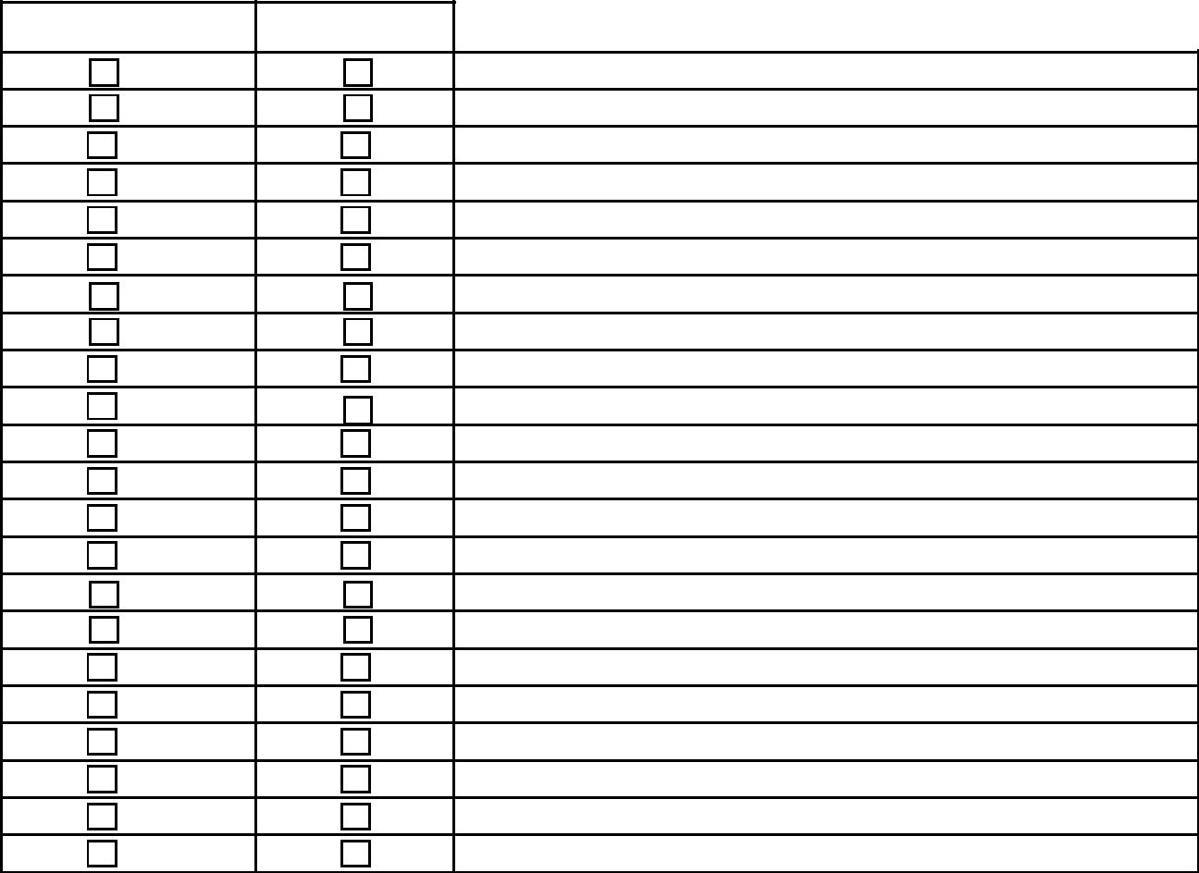

Now Past

heartburn

indigestion

frequent nausea

recurrent vomiting

diarrhea

constipation

bloody stool

light colored stool

rectal pain

rectal itching

worse from missing a meal

bloating

belching

flatulence/passing gas

marked thirst

thirst less

appetite increased

appetite decreased

hurried eating

loss of taste

difficulty swallowing

abdominal or stomach pain

Do you have a strong desire for any particular food? _________________________________________________________

Do you strongly dislike any particular food? _________________________________________________________________

Are there any foods which make you feel bad or aggravate any of your symptoms? _______________________________ _____________________________________________________________________________________________________

Urogenital symptoms

Now Past

frequent urination

painful urination

difficult urination

involuntary urination

strong smelling urine

blood in urine

frequent masturbation

change in sexual energy Please specify: __________________________________________

Male symptoms

Now Past

difficult or loss of erection

painful erections

discharges

lumps or swelling in the testicles

infertility

Female symptoms

Now Past

vaginal infections/discharge

vaginal itching

cervical problems

irregular periods

bleeding between menstrual periods

infertility

PMS

excessive menstrual flow

vaginal dryness

few or no orgasms

pain in breasts

swelling or lumps in breasts

discharge form breasts

When did you begin menstruating? ________________________________________________________________________

How long do your periods usually last? _____________________________________________________________________

Number of pregnancies: ____________________ | Number if births: __________ |  | Caesareans: ________
Miscarriages: _____________________________ | Abortions: _______________
Any complications during pregnancy? | Yes | No | If so, what? ________________________
Did you breastfeed your children? | Yes | No | If so, how long? _____________________

Respiratory symptoms

Now Past

Persistent/recurrent hoarseness

loss of voice

persistent throat pain

chronic throat infections

swollen tonsils

frequent chest colds

wheezing

persistent cough

coughing up mucus

coughing up blood

pain on breathing

difficulty breathing when walking

difficulty when climbing stairs

difficulty when lying

Cardiovascular symptoms

Now Past

palpitations

chest pain at rest

chest pain with walking/exertion

ankle or leg swelling

leg pain unrelated to injury

easy bruising or bleeding, from where?

Skin symptoms

Now Past

rough skin, dry skin

itching

rashes

moles

nail changes

shingles/herpes

pimples

boils

warts

cysts

infections

hives or urinary

swollen glands, location?

eczema, location?

pustules

discoloration, what color?

easy bruising

skin cracks, location?

Musculoskeletal symptoms

Now | Past | Location

pain

stiffness

swelling

numbness

tightness

burning/heat

coldness

twitching

tremors

weakness

paralysis

Please list any symptoms not covered in the sections above, or add any information to help:

Clarify your history: ____________________________________________________________________________________

